Project Title: Breast Cancer Classification Using Convolutional Neural Networks (CNN) - A Case Study

Cancer Net

Abstract

- Breast cancer is a significant global health concern, emphasizing the importance of early detection for successful treatment and increased survival rates.
- This study is dedicated to creating a strong breast cancer categorization system using Convolutional Neural Networks (CNNs) to analyse histology pictures.
- The dataset consists of images categorized as either benign or malignant, serving as a basis for training the CNN model, known as "Cancer Net."
- The main goal of this initiative is to achieve precise classification of these images, contributing to early detection and potentially minimizing unnecessary treatments.
- By utilizing the Kera’s library for CNN architecture, the project strives to provide a practical and highly accurate solution for breast cancer identification in medical environments.
- The focus is on developing a reliable system that can assist in the early diagnosis of breast cancer, ultimately leading to improved patient outcomes.
- Through the use of advanced technology like CNNs, the project aims to revolutionize the way breast cancer is detected and classified.
- The ultimate aim is to enhance the efficiency and accuracy of breast cancer diagnosis, ultimately benefiting patients and healthcare providers alike.
- By leveraging cutting-edge tools and techniques, this project seeks to make a significant impact on the field of breast cancer research and treatment.
- The development of "Cancer Net" represents a crucial step towards improving the early detection and treatment of breast cancer, ultimately saving lives.

Table of Contents

- Introduction
- Literature Review
- Problem Statement
- Data Collection and Preprocessing
- Methodology
- Implementation
- Results
- Discussion
- Conclusion
- Appendices
- Acknowledgments

Introduction

- Breast cancer ranks among the most common cancers affecting women globally, contributing significantly to cancer-related illness and death.
- Timely detection of breast cancer can greatly enhance treatment success and increase survival chances.
- Recent innovations in artificial intelligence (AI) and machine learning (ML) have paved the way for improved diagnostic precision in medical imaging.
- This initiative focuses on creating an AI-driven classifier aimed at identifying breast cancer through a collection of histology images.
- The project will utilize a convolutional neural network (CNN), a deep learning architecture particularly effective for analysing image data, to distinguish between benign and malignant tumours.
- The goal is to support the ongoing integration of AI technologies in healthcare, offering tools that aid healthcare providers in the early identification of cancer.
- By improving early detection, the project aims to enhance patient outcomes and streamline treatment strategies.
- The use of advanced AI techniques could revolutionize how breast cancer is diagnosed and treated.
- This research represents a significant step towards harnessing technology for better health solutions.
- Ultimately, the project aspires to make a meaningful impact on the fight against breast cancer through innovative diagnostic methods.

Literature Review

- Machine learning is increasingly being used in medical diagnostics, especially in classifying medical images.
- CNNs have proven to be effective in image classification tasks, including detecting cancer.
- CNNs can automatically learn and extract features from raw image data, making them ideal for analysing complex patterns in medical images.
- Previous research in breast cancer classification has explored various machine learning techniques, from traditional methods to deep learning models.
- Traditional methods require manual feature extraction, while CNNs can autonomously learn hierarchical feature representations.
- CNNs provide a significant advantage in terms of accuracy and efficiency in medical image analysis.
- Dealing with high-dimensional data poses challenges in medical image analysis.
- Large, annotated datasets are crucial for training deep learning models in medical image analysis.
- Recent advancements in CNN architectures, such as Reset, Dense Net, and Inception, have shown improved classification performance in medical imaging applications.
- The strengths of CNNs in medical image analysis are highlighted in this literature review.

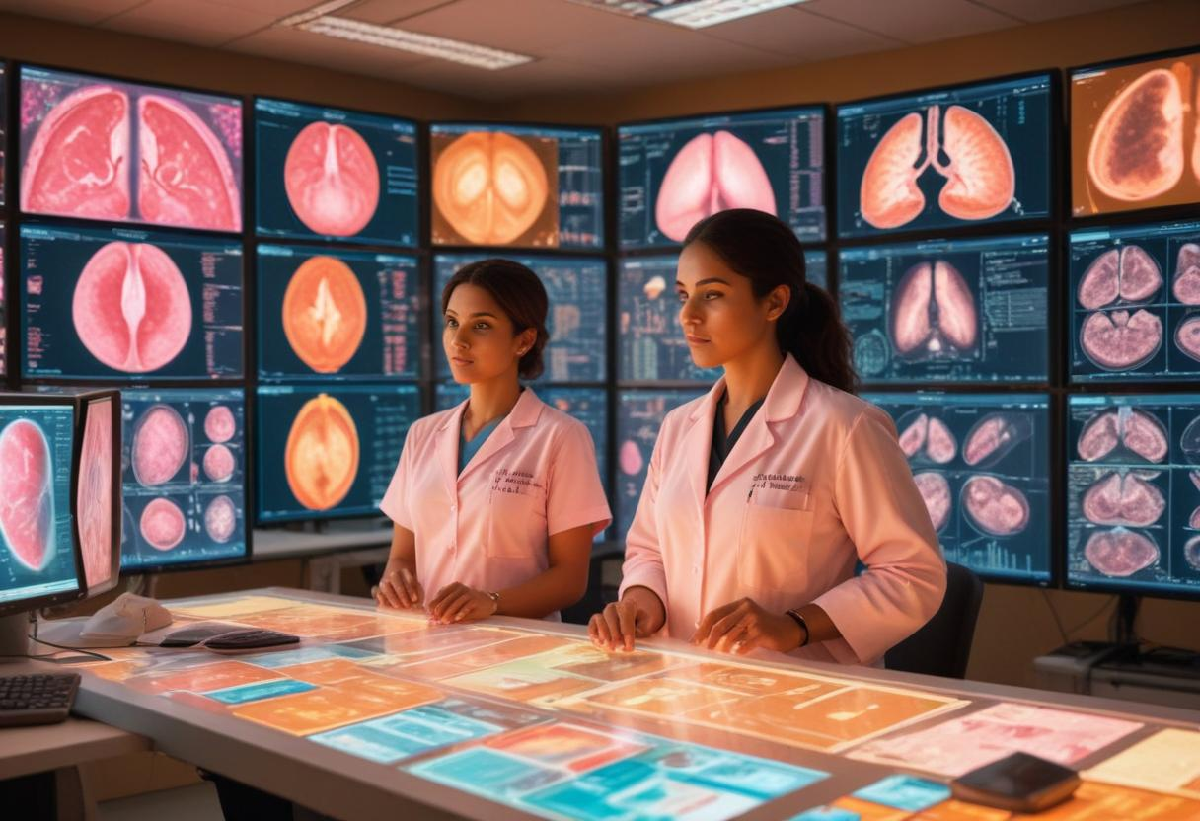

Problem Statement

- This project tackles the crucial task of classifying breast cancer histology images into benign or malignant categories with precision.
- Breast cancer, especially the invasive ductal carcinoma (IDC) subtype, represents a major health threat and is a primary contributor to cancer-related fatalities.
- Timely and precise identification of IDC is essential for enhancing patient prognosis and treatment outcomes.
- However, the traditional method of analysing histology images by pathologists is labour-intensive and often subject to inconsistencies.
- The aim is to create a CNN-based classifier that aids in the swift detection and categorization of breast cancer, promoting prompt clinical actions.
- This initiative aspires to develop a model that not only excels in classification accuracy but also adapts effectively to new, previously unseen data.
- By concentrating on a dataset of breast cancer histology images, the project intends to deliver a tool that could be seamlessly integrated into clinical practices.
- This tool would support pathologists in achieving more precise and efficient diagnoses, ultimately benefiting patient care.
- The focus on early detection and classification is vital for improving treatment strategies and patient survival rates.
- Overall, the project aims to bridge the gap between advanced technology and clinical application, enhancing the diagnostic process in breast cancer care.

Data Collection and Preprocessing

- This research utilizes a dataset comprising 277,524 patches of 50x50 pixel histology images, sourced from 162 whole mount slide images of breast cancer samples.
- Referred to as Cancer Net, the dataset encompasses both benign and malignant cases, featuring 198,738 negative (benign) and 78,786 positive (malignant) samples.
- The images are publicly accessible, offering a solid basis for training and assessing the CNN model.
- The preprocessing stage includes several essential steps: initially, normalizing pixel values to a range that is optimal for neural network input.
- Next, data augmentation methods such as rotation, flipping, and zooming are applied to enhance the diversity of the training set, thereby boosting the model's generalization abilities.
- Additionally, the dataset is divided into training and testing subsets, typically following an 80/20 split, to ensure the model's performance is gauged on previously unseen data.
- This section emphasizes the significance of maintaining a balanced representation of classes within both the training and testing sets.
- An imbalanced dataset can result in skewed model predictions, which is why careful attention to class distribution is crucial.
- The combination of these preprocessing techniques aims to optimize the model's learning process and predictive accuracy.
- Overall, the Cancer Net dataset serves as a valuable resource for advancing research in breast cancer detection and classification.

Methodology

- The methodology segment details the framework and execution of the Cancer Net CNN model.
- Convolutional Neural Networks (CNNs) are selected for this initiative due to their established success in image classification, especially within the healthcare sector.
- The Cancer Net architecture comprises several essential elements: an input layer, various convolutional layers with different filter dimensions, activation functions (REL), pooling layers for reducing dimensionality, and fully connected layers for the final classification.
- To combat overfitting, dropout layers are utilized, which randomly deactivate a portion of neurons during the training phase.
- The model employs the Adam optimizer and uses categorical cross-entropy as the loss function, suitable for the binary classification challenge.
- Training occurs over multiple epochs, allowing the model to refine its parameters by minimizing the loss function through backpropagation.
- Hyperparameter tuning is conducted to enhance the model's effectiveness, focusing on the learning rate, batch size, and the number of training epochs.
- This section also elaborates on the evaluation metrics implemented to measure the model's performance, including accuracy, precision, recall, and F1-score.
- The rationale for choosing these specific metrics is discussed to provide insight into their relevance for the classification task.
- Overall, this methodology aims to create a robust model capable of accurately classifying cancer images.

Implementation

- The next step is to put the CNN model into action using Kera’s library in Python.
- Before that, the data needs to be pre-processed and augmented for better results.
- The Cancer Net model is where the data is fed for training.
- Training happens over multiple epochs, starting with a lower number and increasing gradually.
- To avoid overfitting, early stopping and model checkpointing techniques are used.
- Visualizing the training process is crucial, like plotting loss and accuracy curves over epochs.
- Detailed code snippets are provided for each stage, from data loading to model evaluation.
- Considering the computational resources needed is important, especially when dealing with large-scale image datasets.
- GPUs can be utilized to speed up the training process.
- Challenges related to working with large image datasets are also discussed in the implementation phase.



Results

- The outcomes of the Cancer Net model's training and evaluation are detailed in the results section.
- Accuracy, precision, recall, and F1-score metrics are provided for both the training and testing sets.
- The confusion matrix visually represents the model's performance, showing true positive, true negative, false positive, and false negative predictions.
- The model's ability to correctly classify benign and malignant cases is highlighted, pointing out any discrepancies between predicted and actual labels.
- The impact of hyperparameter tuning on the model's performance is discussed, including different learning rates, batch sizes, and epochs.
- Visualizations like ROC curves and precision-recall curves are included to further explain the model's classification capabilities.
- A comparison with other state-of-the-art methods in the literature is made to showcase the effectiveness of the Cancer Net architecture in breast cancer classification.
- The results section provides a comprehensive overview of the model's performance and capabilities.
- Insights into the model's strengths and areas for improvement are discussed in detail.
- Overall, the results section demonstrates the robustness and accuracy of the Cancer Net model in classifying breast cancer cases.

Discussion

- The results are analysed in the discussion section, focusing on the strengths and limitations of the Cancer Net model.
- The Cancer Net model's exceptional accuracy and precision in classifying breast cancer histology images are emphasized.
- The model's ability to generalize to new data is highlighted through performance metrics on the testing set.
- Potential sources of error, such as class imbalance and image quality variations, are addressed in the discussion.
- Ethical considerations regarding the use of AI in medical diagnostics are explored, stressing the importance of model transparency and human oversight.
- Alternative approaches, like different CNN architectures or additional features such as patient demographics, are considered to improve the model's predictive capabilities.
- Practical implications of implementing the model in a clinical setting are discussed, including the necessity of regulatory approval and challenges in integrating AI tools into healthcare workflows.

Conclusion

- The project's findings highlight the effectiveness of the Cancer Net CNN model in accurately classifying breast cancer histology images.
- Deep learning techniques showcased in the project have the potential to revolutionize early cancer detection methods.
- Medical professionals can benefit greatly from the support provided by these advanced technologies in diagnosing and treating breast cancer.
- Ongoing research and development are crucial in further refining and validating the model's performance on a larger scale.
- Collaboration between AI researchers, medical professionals, and healthcare institutions is essential for the responsible and ethical use of AI in the medical field.
- The real-world application potential of the project's outcomes is a significant aspect that needs to be explored further.
- The project aligns with the broader goal of leveraging technological innovation to enhance healthcare outcomes.
- The promising tool developed for early breast cancer detection has the potential to make a significant impact on patient care.
- The conclusion emphasizes the importance of continuous improvement and advancement in this critical area of healthcare.
- The project's contribution to improving healthcare outcomes through innovation is a testament to the power of technology in the medical field.

Project Steps and Analysis

Data Preparation

- Start by obtaining the Cancer Net dataset from Kaggle, which includes 277,524 histology image patches.
- The dataset categorizes the images as benign or malignant, representing the two main classes for classification.
- Split the dataset into 80% for training and 20% for testing to ensure the model is evaluated on unseen data.
- Apply data augmentation techniques like rotation, flipping, and zooming to increase the diversity of the training set and prevent overfitting.
- Normalize the images to ensure consistent input values for the CNN model.
- This preparation phase is crucial for achieving high classification accuracy and ensuring the model can generalize to new data.
- The 80/20 split ensures that the model is evaluated on unseen data, providing an accurate measure of its generalization capabilities.
- The dataset contains 277,524 histology image patches, labelled as either benign or malignant.
- Data augmentation techniques are applied to increase the diversity of the training set and prevent overfitting.
- Normalizing the images ensures consistent input values for the CNN model, contributing to high classification accuracy.

Model Architecture (Cancer Net)

- Cancer Net utilizes the Kera’s library to create a CNN architecture for feature extraction from histology images.
- The model includes multiple convolutional layers, each with a REL activation function and a max-pooling layer.
- Convolutional layers capture spatial hierarchies, while pooling layers reduce dimensionality to prevent overfitting.
- Fully connected layers are added, leading to a SoftMax activation function for binary classification.
- The model is compiled using the Adam optimizer, known for efficient handling of sparse gradients.
- Categorical cross-entropy is used as the loss function.
- Dropout layers are included to further mitigate overfitting and ensure model robustness.
- The focus is on building a CNN architecture that effectively extracts features from histology images.
- The model is designed using the Kera’s library, with a strong emphasis on feature extraction.
- The architecture includes several convolutional layers, REL activation functions, max-pooling layers, and fully connected layers for binary classification.

Training and Evaluation

- The Cancer Net model undergoes training on a meticulously prepared dataset for a set number of epochs, with the implementation of early stopping to prevent overfitting.
- During the training process, the network's weights and biases are fine-tuned through backpropagation, gradually minimizing the loss function.
- The model's performance is assessed based on accuracy, precision, recall, and F1-score, giving a holistic understanding of its classification abilities.
- Additionally, a confusion matrix is created to delve deeper into the model's predictions, showcasing the rates of true positives, true negatives, false positives, and false negatives.
- This thorough analysis aids in pinpointing any potential biases within the model and highlights areas that could benefit from enhancement.
- The Cancer Net model is meticulously trained on a curated dataset for a specific number of epochs, with early stopping integrated to prevent overfitting.
- Throughout the training process, the network's weights and biases are fine-tuned via backpropagation, progressively reducing the loss function.
- Evaluation of the model's performance is based on metrics such as accuracy, precision, recall, and F1-score, offering a comprehensive overview of its classification performance.
- Furthermore, a confusion matrix is generated to provide detailed insights into the model's predictions, including the rates of true positives, true negatives, false positives, and false negatives.
- This in-depth analysis is crucial in identifying any potential biases present in the model and areas that could be enhanced for better performance.

Performance Analysis and Real-World Application

- A thorough analysis is conducted on the Cancer Net model's performance, focusing on both its strengths and weaknesses.
- The model's crucial ability to accurately identify malignant cases, especially in the early detection of breast cancer, is highlighted for its potential to improve patient outcomes.
- The discussion delves into the potential for overfitting or underfitting, exploring measures like cross-validation and regularization techniques as possible solutions.
- Real-world applications of the model, such as its integration into diagnostic workflows in hospitals and clinics, are explored in the project's conclusion.
- The ethical implications of utilizing AI for medical diagnosis are addressed, emphasizing the importance of transparency, fairness, and human oversight in AI-powered healthcare solutions.
- The Cancer Net model's performance is thoroughly examined, with a focus on its strengths and weaknesses.
- The model's ability to accurately detect malignant cases, particularly in the early detection of breast cancer, is emphasized for its potential to improve patient outcomes.
- The discussion considers the potential for overfitting or underfitting, with measures like cross-validation and regularization techniques discussed as potential solutions.
- Real-world applications of the model, such as integrating it into diagnostic workflows in hospitals and clinics, are explored in the project's conclusion.
- The ethical implications of using AI for medical diagnosis are addressed, emphasizing the need for transparency, fairness, and human oversight in AI-powered healthcare solutions.

Key Questions and Insights

Training and Testing Split

- The dataset is divided into 80% for training and 20% for testing, providing a solid framework for assessing the model's ability to generalize.
- This division is a standard practice in machine learning, striking a balance between a substantial training set and the necessity for adequate evaluation data.
- By allocating 80% of the data for training, we ensure the model learns effectively while reserving 20% for thorough testing.
- This commonly adopted split ratio helps maintain the integrity of the evaluation process, allowing for a comprehensive analysis of the model's performance.
- Such a strategic partitioning is essential for developing models that not only learn well but also perform reliably on unseen data.
Number of Epochs

- The model undergoes training for numerous epochs, and early stopping is implemented according to the validation loss.
- The number of epochs can differ based on the model's convergence, with popular options being 5, 10, or more epochs, depending on the data complexity and model design.
- The model is trained for various epochs, and early stopping is utilized based on the validation loss.
- The specific number of epochs can vary depending on the model's convergence, with common choices including 5, 10, or more epochs, depending on the complexity of the data and the model architecture.
- Training the model involves multiple epochs, and early stopping is applied based on the validation loss, with the number of epochs varying depending on the model's convergence and the complexity of the data and architecture.
Suitability of CNNs for Image Data

- CNNs are often hailed as the top option for image data because of their knack for grasping spatial hierarchies and extracting features straight from pixel values.
- Transfer Learning with pre-trained networks (such as VGG16, Reset) presents a viable alternative to CNNs for achieving superior performance.
- Delving into other deep learning architectures like Capsule Networks could potentially yield even better results than traditional CNNs.
- Exploring different methods beyond CNNs, such as Transfer Learning and Capsule Networks, can lead to enhanced performance in image data tasks.
- While CNNs are a popular choice, considering alternative approaches like Transfer Learning and Capsule Networks may unlock new possibilities for improving model performance in image data analysis.
Accuracy After 5 and 10 Epochs

- The model's precision is anticipated to enhance as more epochs are run, but there is a possibility of overfitting if the model is trained excessively.
- The exact accuracy metrics will vary based on the dataset and architecture, but improvements are usually seen early on in the training process.
- With each additional epoch, the model's accuracy is likely to increase, but caution must be taken to avoid overfitting.
- The accuracy of the model is projected to get better with increased epochs, although there is a risk of overfitting if training is prolonged.
- Typically, noticeable enhancements in accuracy are observed within the initial few epochs, depending on the dataset and model architecture.

Model Evaluation: Overfitting vs. Underfitting

- Analysing the model's performance helps identify if it is overfitting, underfitting, or making optimal predictions.
- Overfitting may happen when the model excels on training data but struggles on test data.
- Underfitting suggests that the model has not grasped the data's patterns effectively.
- An optimal model finds the right balance, delivering strong results on both training and test datasets.
- By assessing performance, we can determine if the model is overfitting, underfitting, or achieving optimal predictions.

Real-Life Application and Future Steps

- The Cancer Net model has the potential to seamlessly fit into clinical workflows, aiding pathologists in accurately diagnosing breast cancer from histology images in practical situations.
- Moving forward, enhancements to the model could involve fine-tuning it with a wider range of datasets, tackling any biases present, and investigating new functionalities or incorporating multi-modal data (such as merging imaging data with patient background) to enhance diagnostic precision.
- Additionally, it is crucial to ensure that the model adheres to medical regulations and ethical guidelines to guarantee its effective implementation in healthcare environments.
- The integration of the Cancer Net model into clinical practices could revolutionize the process of diagnosing breast cancer from histology images, providing valuable support to pathologists.
- To further improve the model, future steps may include optimizing it with more diverse datasets, mitigating potential biases, and exploring additional features or multi-modal data integration for enhanced diagnostic accuracy.
- It is imperative to prioritize the model's compliance with medical standards and ethical norms to ensure its successful deployment in healthcare settings.
- The Cancer Net model has the potential to significantly enhance the diagnostic capabilities of pathologists when it comes to identifying breast cancer from histology images in real-world scenarios.
- Enhancing the model with a broader range of datasets, addressing biases, and exploring new features or multi-modal data integration could be key steps in advancing its diagnostic accuracy.
- Ensuring that the model meets medical regulations and ethical standards is essential for its seamless integration into healthcare workflows and successful utilization by pathologists.
- The Cancer Net model's integration into clinical workflows could streamline the process of diagnosing breast cancer from histology images, offering valuable assistance to pathologists in real-life situations.

